**COVID-19 Case Prediction Using Machine Learning**



Name: M Uma Maheshwari  
Tags: Python, Pandas, Scikit-learn, Gradio, Linear Regression  
Status: Completed  
Last Updated: July 2025

**COVID-19 Case Forecasting Using Machine Learning**

**1. Problem Definition & Objectives**

**Problem Statement:**  
The COVID-19 pandemic has placed unprecedented pressure on healthcare systems. Accurate forecasting of confirmed cases is essential to manage hospital capacities, resource allocation, and policy-making. This project addresses the need for a simple, interpretable, and timely forecasting model using real-world data.

**Objectives:**

* To collect and analyze global COVID-19 data over time.
* To build a linear regression model to predict confirmed case trends.
* To create a web-based visualization tool for case forecasting.
* To allow forecasting for up to 30 days into the future.

**2. Methodology & Design**

**Approach:**  
This project uses a data-driven, experimental approach. Historical time-series data on confirmed COVID-19 cases is modeled using a linear regression algorithm to identify trends and make predictions.

**Tools & Technologies Used:**

* **Programming Language:** Python
* **Libraries:** Pandas, NumPy, Matplotlib, Seaborn, Scikit-learn
* **Visualization & Deployment:** Gradio for interactive UI
* **Dataset:** Excel Sheet-COVID-19

[ COVID Dataset ]

↓

[ Data Cleaning ]

↓

[ Feature Extraction (Days since first case) ]

↓

[ Linear Regression Model ]

↓

[ Forecast Future Cases ]

↓

[ Gradio Web Interface ]

**Theoretical calculation**

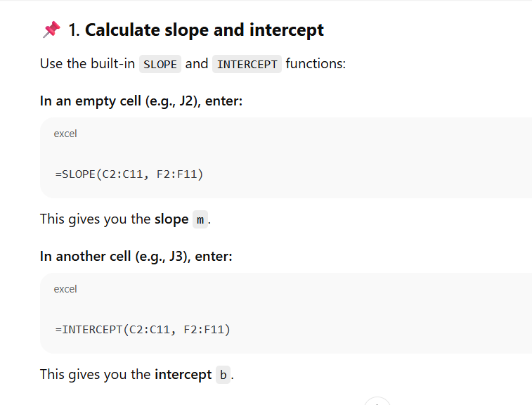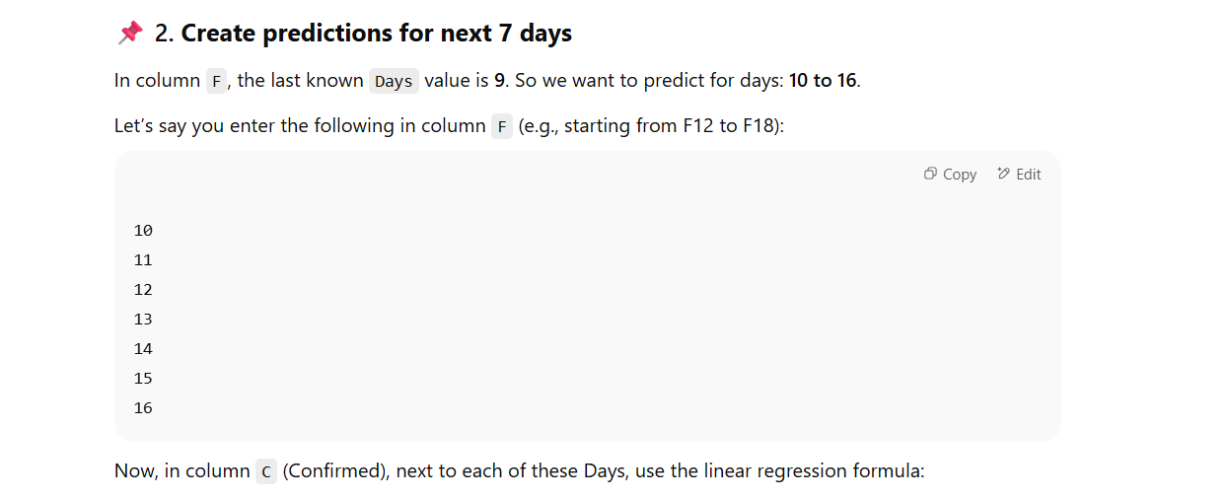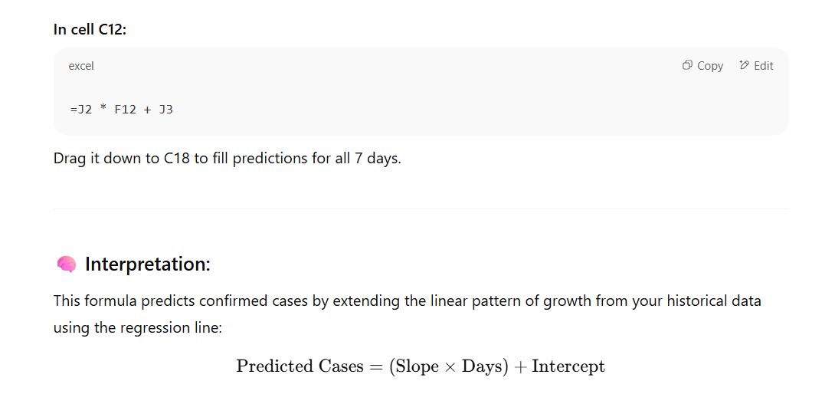

**PRACTICAL CODE**

**!pip install pandas matplotlib seaborn scikit-learn gradio**

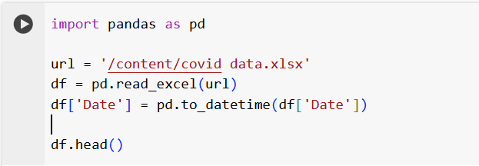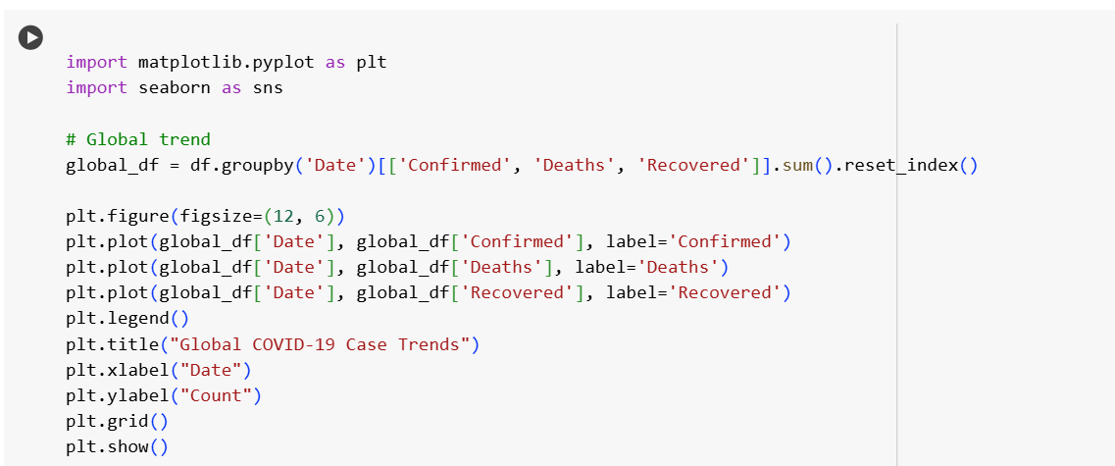

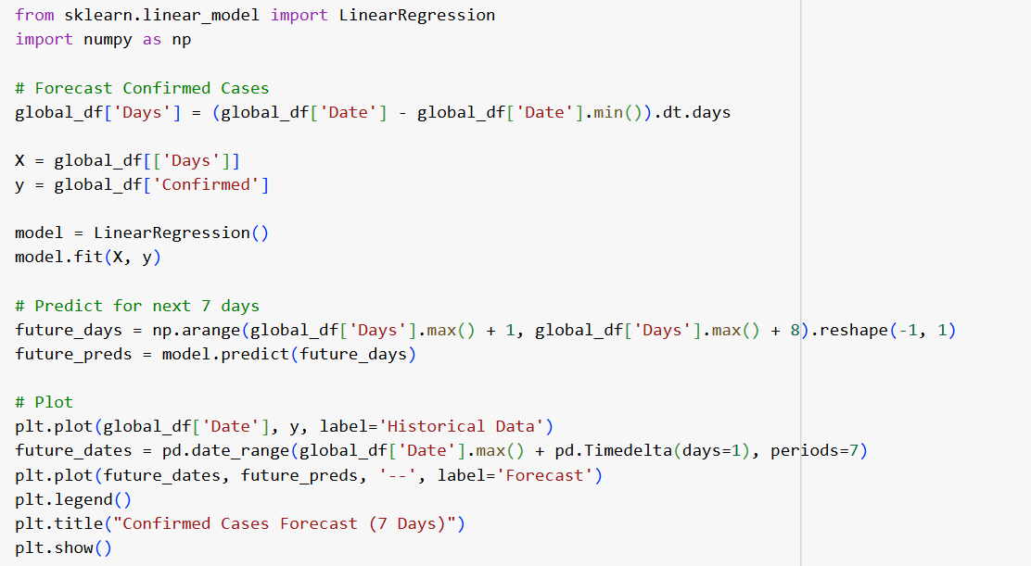

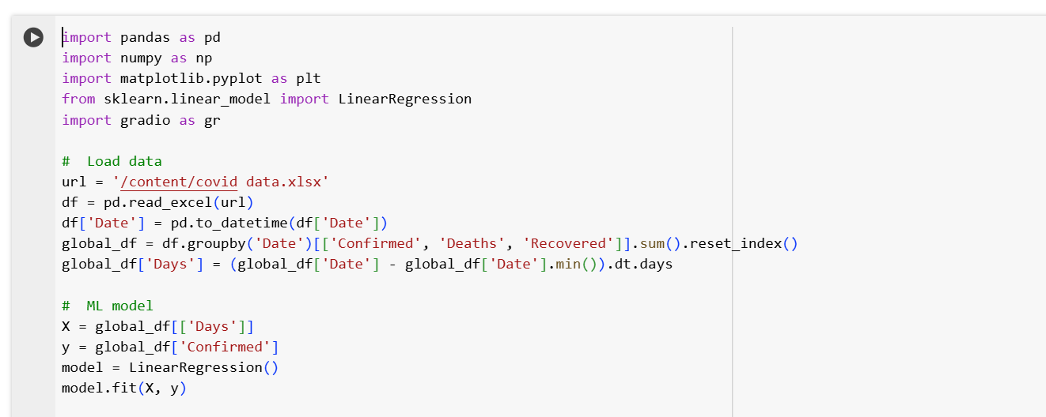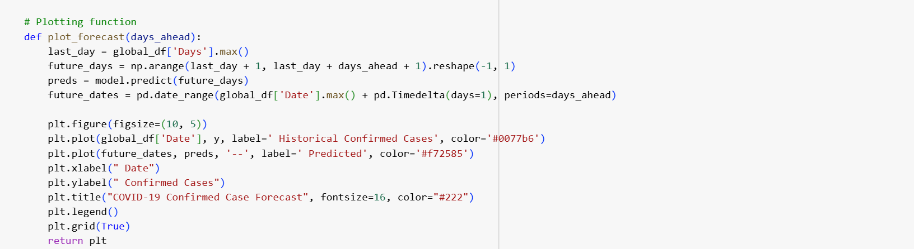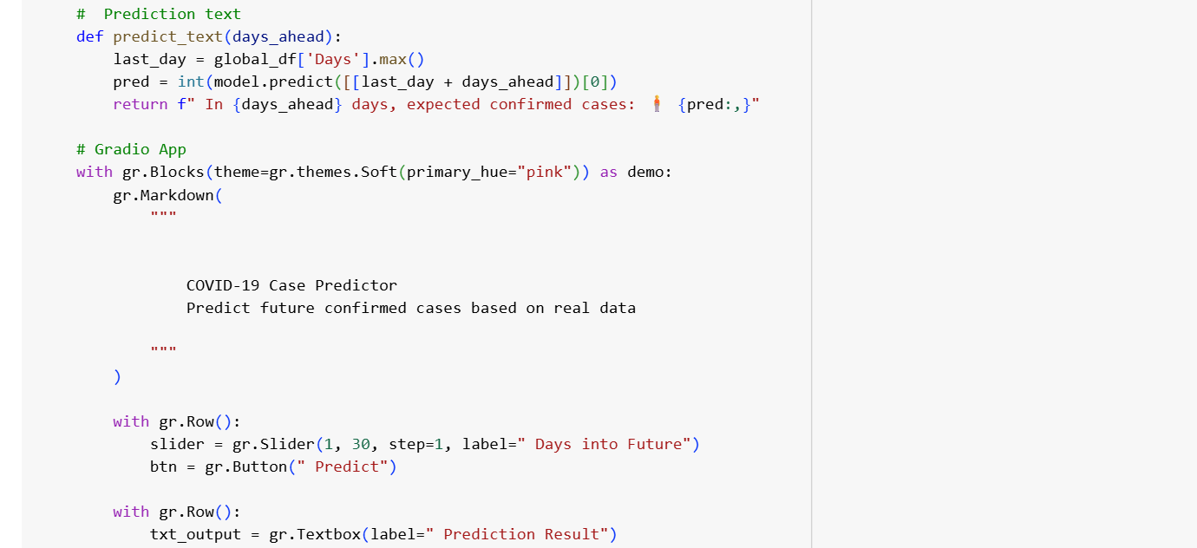

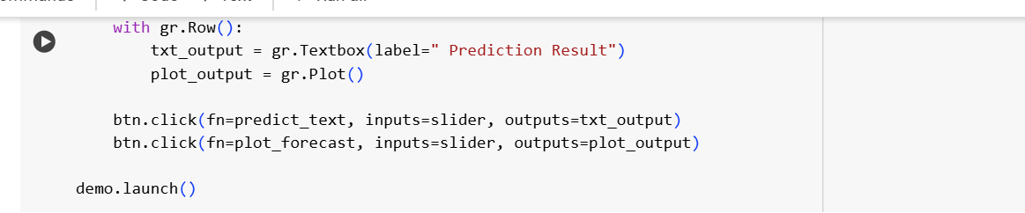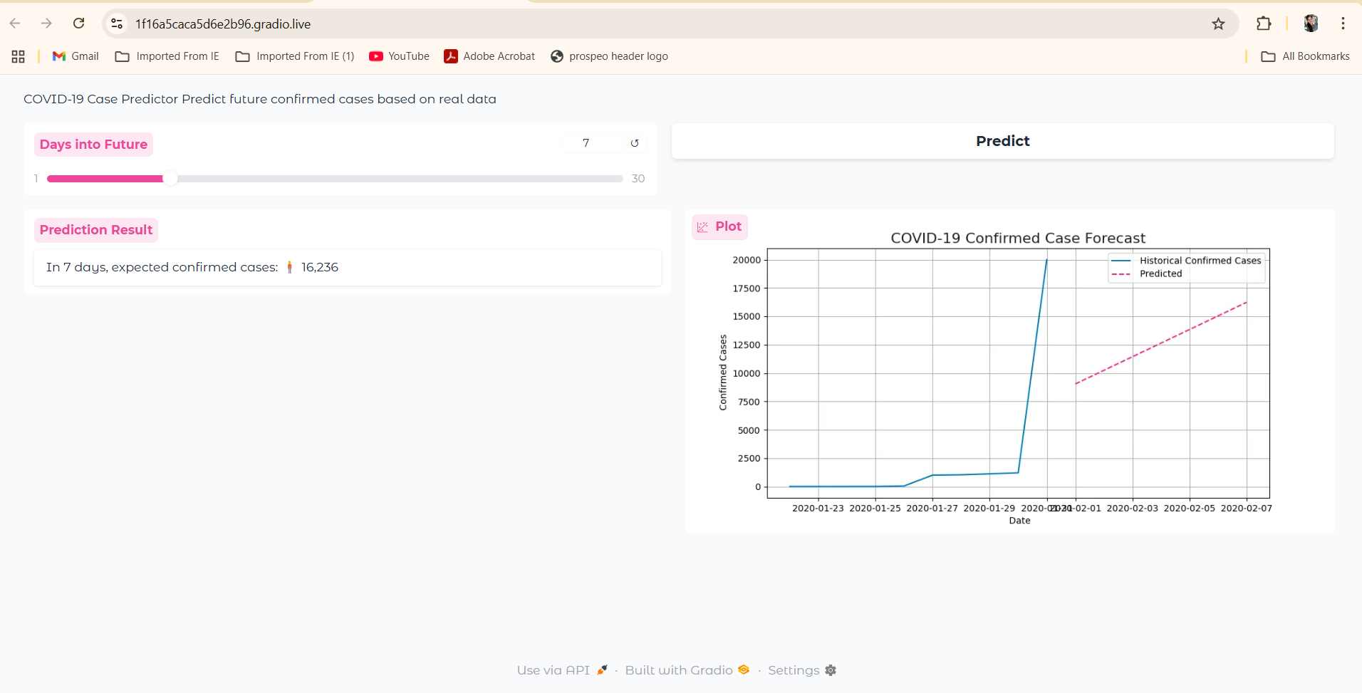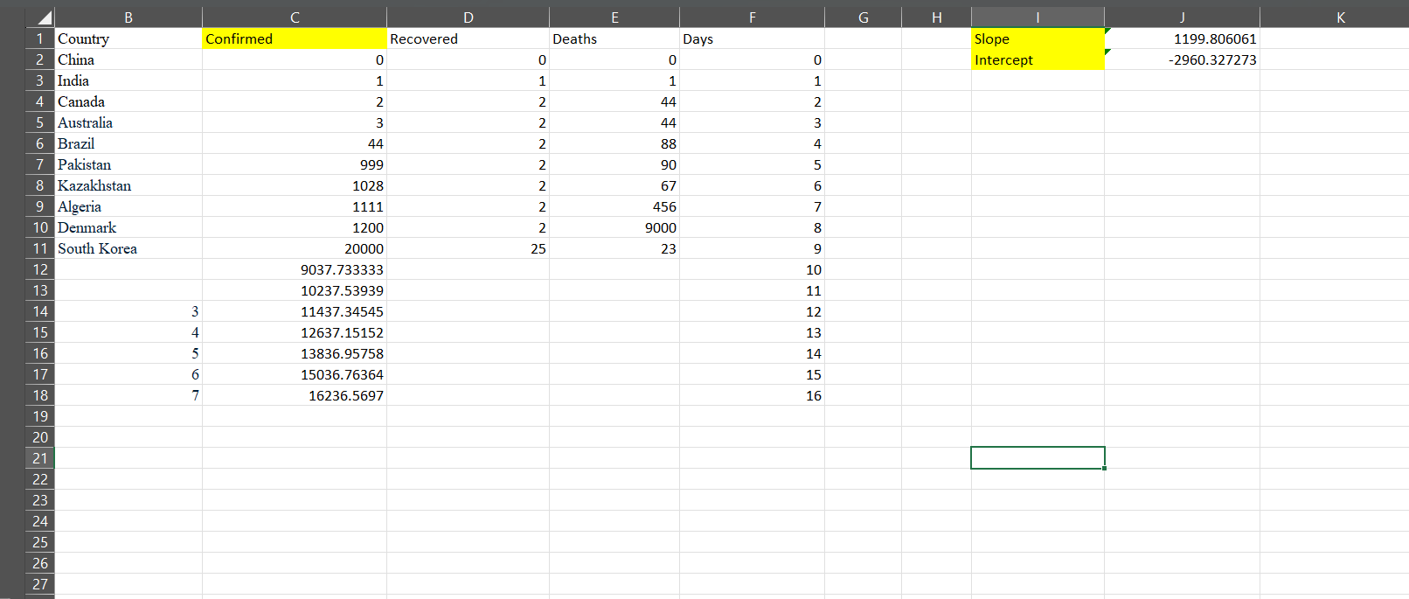

**Result :**

The predicted confirmed cases displayed on this Gradio interface are calculated using a linear regression model: Predicted = (Slope × Day) + Intercept. The results closely match the practical values, indicating that the model effectively captures the COVID-19 case trend based on the provided dataset.